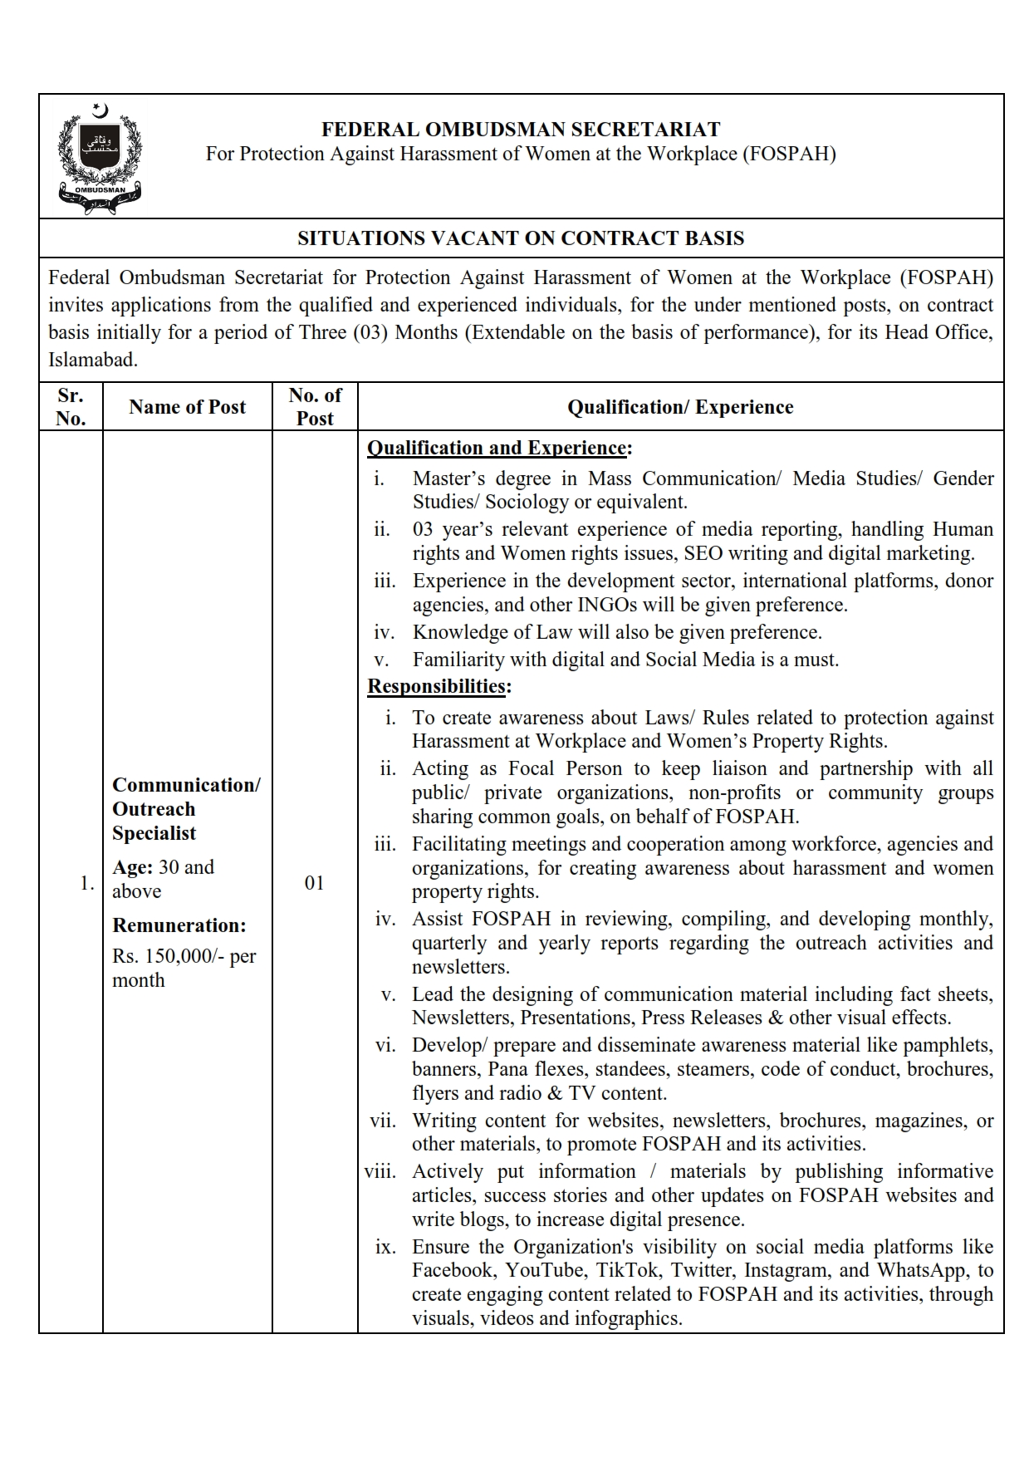
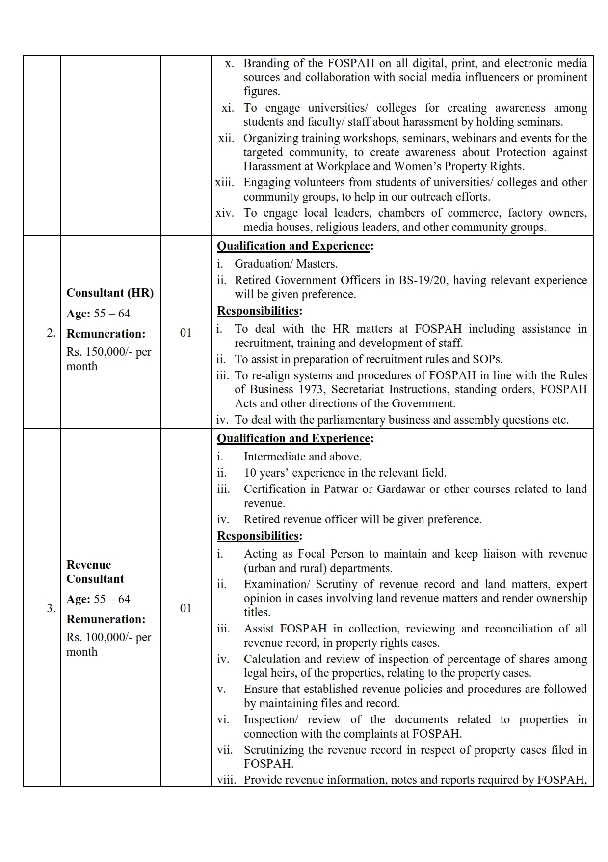
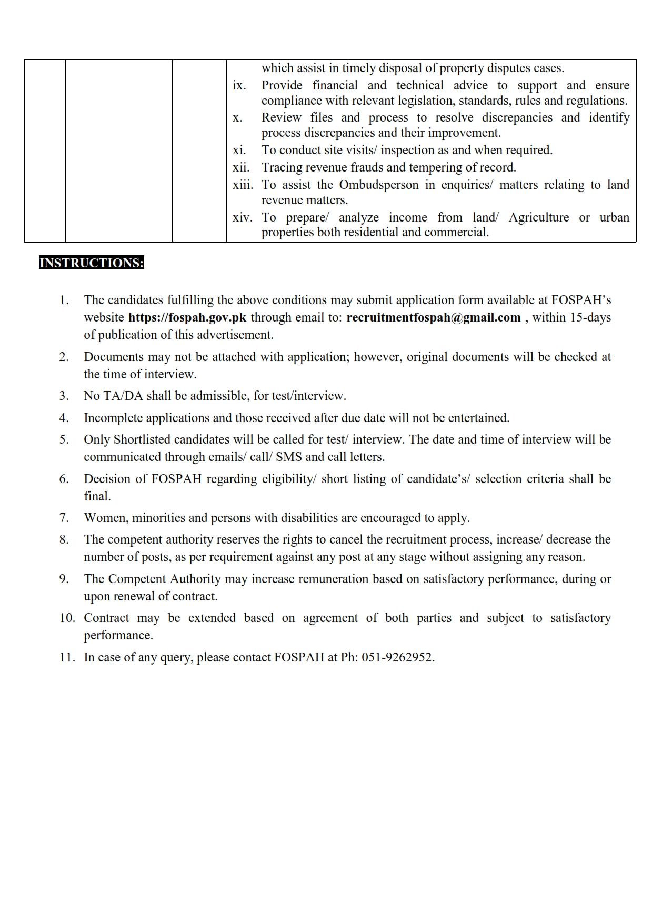

APPLICATION FORM
(Fill in Block Letters)

Position Title
CNIC No.
Religion
Name
Father’s Name
Date of Birth |  |  |  |  |  |  | - |  |  |  |  |  |  |  | - |  |  |  |  |  |  |  |  |  |  |  |  |  | Domicile
 |  |  | d d m m y y y y
Gender |  |  |  |  | Male |  |  |  |  |  |  |  |  |  |  |  |  |  |  | Female |  |  |  |  |  |  |  |  |  |  |  |  |  |  |  |  |  |  |  |  |  |  |  |  |  | Marital Status
E-mail Address
Postal Address
City |  |  |  |  |  |  |  |  |  |  |  |  |  |  |  |  |  |  |  |  |  |  |  |  |  |  |  |  |  |  |  |  |  |  |  |  |  |  |  |  |  |  |  |  | Province
Permanent
Address
City |  |  |  |  |  |  |  |  |  |  |  |  |  |  |  |  |  |  |  |  |  |  |  |  |  |  |  |  |  |  |  |  |  |  |  |  |  |  |  |  |  |  |  |  | Province
Phone (Res) |  |  |  |  |  |  |  |  |  |  |  |  |  |  |  |  |  |  |  |  |  |  |  |  |  |  |  |  |  |  |  |  |  |  |  |  |  |  |  |  |  |  |  |  | Mobile

Educational Qualification (Matric and onwards)

Professional Qualification
Sr. | Course/Qualification | Year | Duration (Months) | Institution

Post Qualification Experience (if any)
Sr. | Employer Name | Position Title | Field of Work | From | To

Declaration: I certify that the above information is true to the best of my knowledge and belief.
Incomplete /misinformation would render me ineligible for induction.

Date : |  |  |  | - |  |  | -
Candidate’s Signature__________________

Note:
Interested candidates may send their application forms till 25th August 2023, through email to recruitmentfospah@gmail.com

